ARMORY ART CENTER
811 Park Place, West Palm Beach, FL 33401 | (561) 832-1776
Drawing for Beginners

Material List
- Canson “Biggie” News Print Pad - 18” x 24”
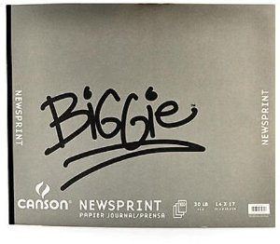

- SOFT Vine/Willow Charcoal
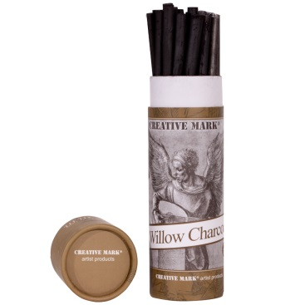
- Prismacolor or Sanford “Design” brand Kneaded erasure
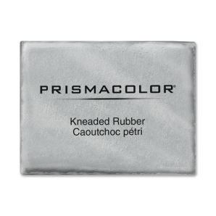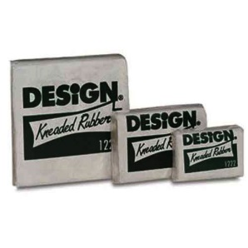

- Ebony Pencil
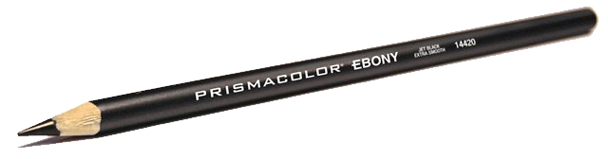
- White Charcoal Pencil (any brand)
- Small “Sketch Book” (For praticing out of class)
WEEKS 1-3. SHAPES
WEEKS 4-6. VALUE
WEEK 7-8. LINE/ REVIEW

Any questions?
Please email the instructor: michael.lascasas@armoryart.org

